

**Narrogin Senior High School ATAR Examination, 2019**

**ATAR MODERN HISTORY**

|  |  |  |
| --- | --- | --- |
| **Source Set** | **Area of Study** | **Related Question** |
| 1 | Australia 1918–1955 | 1 |
| 2 | Russia and the Soviet Union 1914–1945 | 1 |
| 3 | China 1935–1989 | 1 |
| 4 | The changing European world since 1945 | 11 |
| 5 | Australia’s engagement with Asia | 11 |
| 6 | The struggle for peace in the Middle East | 11 |

**SOURCE BOOKLET**

**Set 1: Australia 1918–1955**

**Source 1**

An official photograph from the Commonwealth Department of Defence showing Sister Pearl Corkhill receiving the Australian Military Medal from the Governor-General of Australia in 1924 for her courage and devotion while under air attack from enemy forces in World War One. Corkhill had been a staff nurse in the Australian Imperial Forces.

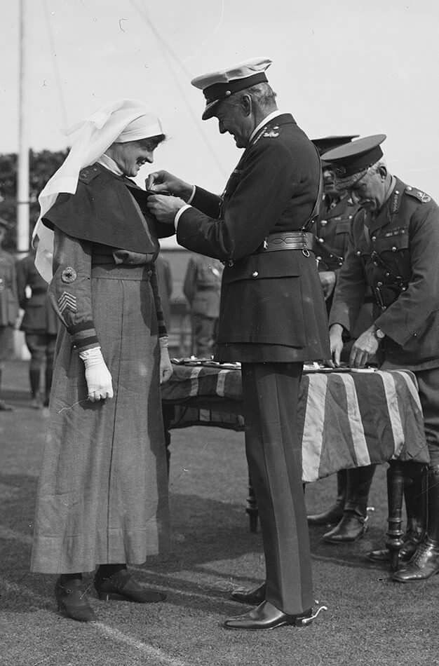

**Source 2**

Comments by an Australian woman in 1946 published in “When the War Came to Australia – personal narratives of World War Two” (1992).

“After the war was over there was a gradual dismissal from the factories. The men came back and took the jobs that the women had obtained, and women went back to the usual women’s jobs — secretary, typist, shop assistant, waitress and so on. It was the same as it had been after the First World War and during the Depression. Some women had been given responsible jobs in quite managerial roles, and they were excellent at it, but the men just took over the jobs that the women were doing so well. The same thing happened to me because as the war ended our organisers were dismissed and finally there were just two — a man and myself — and I was pressured: the man had a family and it was only right that he should continue, and would I resign…So we were really pressured out of our jobs.:

**SEE NEXT PAGE**

**Source 3**

‘Why women vote for Labor’ poster published by the Australian Labor Party WA Branch as part of the campaign for the Federal Elections 1943.

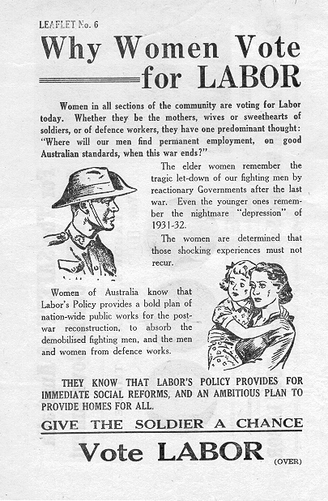

**SEE NEXT PAGE**

**Source 4**

Extract from an article entitled “The role of Australian women at War” by Professor Melanie Oppenheimer is chair of history at Flinders University, South Australia. This article originally appeared in Vogue Australia's November 2018 issue as part of a series called #ThanksForServing - to acknowledge the service of Australian veterans past and present.

“On November 11, 1918, 100 years ago, the guns fell silent on the western front. War has played a major role in our national identity and we have created a rich history around the Anzac legend. But how representative is our war history? I believe that the roles of women in war, both on the war front and the home front, have been downplayed. Perhaps it would not matter, except that much of our national identity is predicated on and around our military history, which largely ignores the roles undertaken by women. They have had an uneasy relationship with the Anzac tradition, with women’s contributions portrayed as being passive supporters rather than as active participants.

The story of Australian women at war is about participation, breaking down barriers and receiving adequate recognition. It is a unique and complex story, because of our obsession with our war history.

We forget, however, how difficult it’s been for women. In World War II, for example, the formation of auxiliary women’s services and the opening up of the employment market through manpower shortages sowed the seeds for gender reform. Despite the fear of women invading the officer’s mess and the threat of women taking men’s jobs, the pressures of the war meant that military leaders and politicians had to relent.”

**END OF SOURCE SET**

**Set 2: Russia and the Soviet Union 1914–1945**

**Source 1**

Photograph taken by the American Red Cross showing Russian women who had fled from the Bolsheviks kneeling before American aid workers at a relief camp Russia 1922. The photograph was labelled “the disintegration of an empire”.

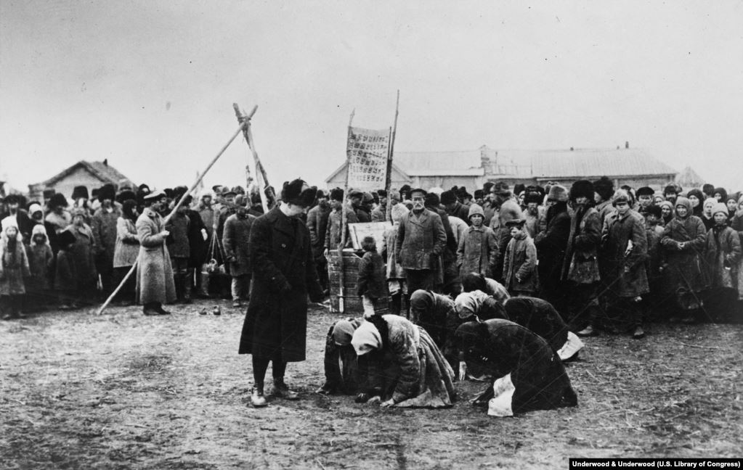

**SEE NEXT PAGE**

**Source 2**

Extract from a speech delivered by Nadezhda K. Krupskaya, November 1933 at the Congress of the Communist International - “Preface to *The Emancipation of Women* *From* *Writings of V.I. Lenin”*

“In October 1932 we observed the fifteenth anniversary of Soviet power and summed up our achievements on all fronts, including the front of women's emancipation.

We know that women took a very active part in the Civil War, that many of them died in action but many others were steeled in battle. Some women were awarded the Order of the Red Banner for the active part they played in the struggle for Soviets during the Civil War.

At the time when we observed the fifteenth anniversary of the October Revolution 20 to 25 per cent of the deputies of the village Soviets, district executive committees and city Soviets were women. There were 186 women members of the All-Russia Central Executive Committee and the Central Executive Committee of the U.S.S.R.

The number of women members of the Communist Party has also been steadily growing. In 1922 there were only 40,000 but by October 1932 the number exceeded 500,000.

Much progress has been made recently in fulfilling Lenin's behest concerning the complete emancipation of women. Every day we see more and more front-rank women workers who display great stamina and perseverance in labour. Labour is not something women have to get used to. Under the old regime the lives of women were full of continual, unending labour, but it was the kind of labour that was looked down upon and bore the imprint of bondage. And now this labour training and perseverance in labour place women in the front ranks of the builders of socialism and heroes of labour.”

**SEE NEXT PAGE**

**Source 3**

Soviet propaganda poster 1944. The caption translates as “Glory to the Mother-Heroine”.

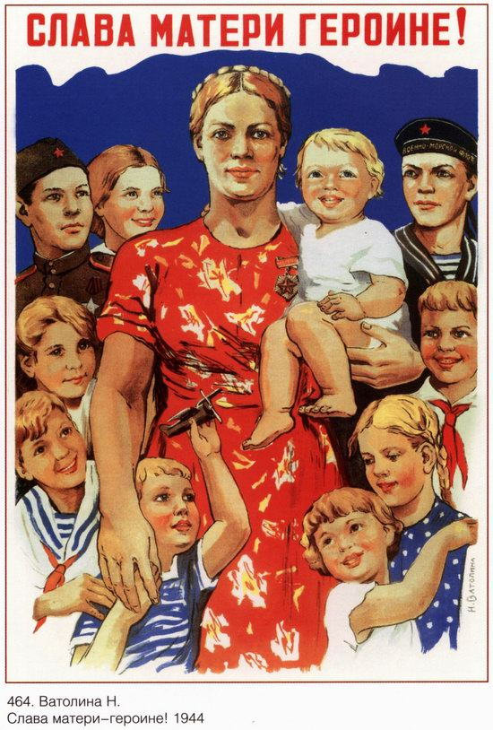

**SEE NEXT PAGE**

**Source 4**

Extract from “Ideology, Gender and Propaganda in the Soviet Union: A Historical Survey” (2002) by Choi Chatterjee, Senior Lecturer in History, California State University. Published as part of the “Celebrating Women Gender Festival”.

“The model of the "New Soviet Woman" served as a justification of the creative and innovative nature of the October Revolution. It was not mere happenstance that the propaganda surrounding both the Lenin and Stalin cults repeatedly emphasized the leaders' care for that politically backward cohort, women. But in the separate models of the "New Soviet Woman" that each period spawned one could gauge the difference between the Lenin and the Stalin cult. In the 1920s, the popular fictions of female destinies were personified in the imaginary denizens of a communist future, or in the pages of literature. Apart from the old Bolshevik female leaders, there were few memorable heroines of the NEP era. Those with claims to fame usually used their valorous participation in the Civil War to signify their importance to the revolution. In the 1930s by contrast under Stalin, the material conditions had changed so dramatically, or so it was claimed in the propaganda, that Soviet heroines (modem women) were to be found in every corner of the Soviet Union. Stalinism failed to fulfil the ideals of October...”

**END OF SOURCE SET**

**Set 3: China 1935–1989**

**Source 1**

Photograph of the McTyeire Graduating Class of 1938. The photo was taken for the official yearbook. The Mc Tyeirer school was established to educate the elite young ladies of Shanghai. The original school was established in 1922.

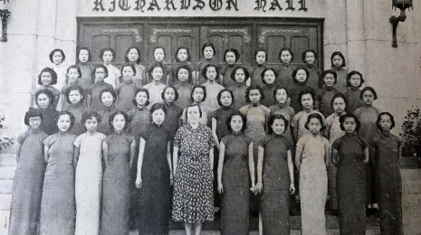

**SEE NEXT PAGE**

**Source 2**

Selected extracts from "Quotations from Chairman Mao Tse-tung", printed in Peking in 1967.

“In order to build a great socialist society, it is of the utmost importance to arouse the broad masses of women to join in productive activity. Men and women must receive equal pay for equal work in production. Genuine equality between the sexes can only be realized in the process of the socialist transformation of society as a whole.”

Introductory note to "Women Have Gone to the Labour Front" (1955), *The Socialist Upsurge in China's Countryside,* Chinese ed., Vol. I.

http://www.art-bin.com/bilder/onepixclear.gif

“With the completion of agricultural cooperation, many co-operatives are finding themselves short of labour. It has become necessary to arouse the great mass of women who did not work in the fields before to take their place on the labour front.... China's women are a vast reserve of labour power. This reserve should be tapped in the struggle to build a great socialist country.”

Introductory note to "Solving the Labour Shortage by Arousing the Women to Join in Production" (1955), *The Socialist Upsurge in China's Countryside,* Chinese ed., Vol. II.

http://www.art-bin.com/bilder/onepixclear.gif

“Enable every woman who can work to take her place on the labour front, under the principle of equal pay for equal work. This should be done as quickly as possible.”

Introductory note to "On Widening the Scope of Women's Work in the Agricultural Co- operative Movement" (1955), *The Socialist Upsurge in China's Countryside,* Chinese ed., Vol. I.

**SEE NEXT PAGE**

**Source 3**

Official poster produced by the Chinese Communist Party in 1975. The caption translates as “Women can hold up half the sky” and shows women working in construction.

[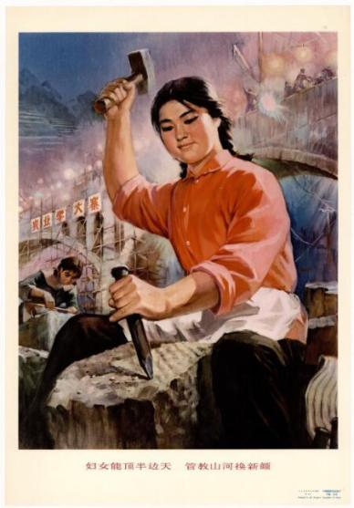](https://messycow.com/2017/01/25/something-about-women-hold-up-half-the-sky/dc98ef7fde22481c896bed1dbb8189a9_th/)

**SEE NEXT PAGE**

**Source 4**

Extract from a paper entitled ‘Women’s Movement and Change of Women’s Status in China’ by Yuhui Li. Li is a PHD student at Renmin University of China. The paper was published in Journal of International Women's Studies (2000), Bridgewater State University. The Journal of International Women’s Studies is an on-line, open-access, peer reviewed feminist journal that provides a forum for scholars, activists, and students to explore the relationships among theories of gender and sexuality.

“The dramatic changes in China since the Cultural Revolution have had a mixed and inconsistent impact on women’s movement and status in China. On the one hand, the literature shows that Chinese women experienced rapid progress in terms of gender equality during the Cultural Revolution. Women’s labor force participation rate, as has been discussed earlier, remained high, and women’s representation in higher educational institutions was also higher during the Cultural Revolution, compared with either earlier or later times. On the other hand, however, there is evidence that women still suffered an extremely low status in Chinese culture. Repeated reports of female infanticide after the implementation of the one-child policy was one of the first messages that alarmed the Chinese as well as the world population as an indicator of the persistence of women’s low status in China. It was during the Cultural Revolution that the All Women’s Federation was forced to suspend itself, an indicator that women’s affairs were placed in a secondary position compared with what the Chinese Party considered as the more pressing political agenda during those years. The ultra-leftist Cultural Revolution Movement that lasted for 10 years completely ignored women’s issues and women were either hardly differentiated from men, or they were simply rendered masculine. The uniform color and style of the popular outfit for both women and men during the Cultural Revolution, and slogans such as “Whatever men can do, women can do too,” using men as the yardstick to evaluate women, attest to this argument.”

**END OF SOURCE SET**

**Set 4: The changing European world since 1945**

**Source 1**

Protest in New York City, October 1962. The photograph was originally published in *the New York Times.*

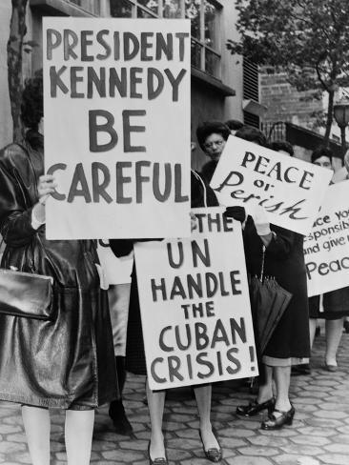

**SEE NEXT PAGE**

**Source 2**

Extract from a letter from Premier Khrushchev (USSR) to President J.F. Kennedy (USA) October 26 1962.

“…It is good, Mr. President, that you agreed for our representatives to meet and begin talks, apparently with the participation of the U.N. Acting Secretary General U Thant. Consequently, to some extent, he assumes the role of intermediary, and we believe that he can cope with the responsible mission if, of course, every side that is drawn into this conflict shows good will.

I think that one could rapidly eliminate the conflict and normalize the situation. Then people would heave a sigh of relief, considering that the statesmen who bear the responsibility have sober minds, and awareness of their responsibility, and an ability to solve complicated problems and not allow matters to slide to the disaster of war.

This is why I make this proposal: We agree to remove those weapons from Cuba which you regard as offensive weapons. We agree to do this and to state this commitment in the United Nations. Your representatives will make a statement to effect that the United States, on its part, bearing in mind the anxiety and concern of the Soviet state, will evacuate its analogous weapons from Turkey. Let us reach an understanding on what time you and we need to put this into effect.

After this, representatives of the U.N. Security Council could control on-the-spot the fulfillment of these commitments…”

**SEE NEXT PAGE**

**Source 3**

Cartoon from Punch Magazine, October 17, 1962 entitled ‘Over The Garden Wall’. Punch was a highly successful British publication (1841-2002) with a focus on humour and satire in relation to significant events, people etc.

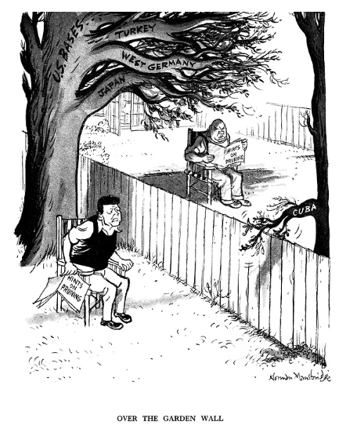

**SEE NEXT PAGE**

**Source 4**

Extract from an interview with Sergei Khrushchev with the U.S. Naval Institute (2012). Sergei is the son of Nikita Khrushchev, the Premier of the Soviet Union during the Cuban Missile Crisis. He shared his impressions of that showdown from a Soviet perspective and the lessons for current and future leaders.

“The Russians’ misconception was their own mentality. The enemy at the gate, missiles on your borders—like anything—is part of their historical experience. The Europeans had enemies at the gates for all of their history... The American bases that surrounded Soviet Union— and when Americans placed missile bases in Turkey or any other European country—didn’t create any panic because the obligation of the government was to deal with the opposite side. Americans were lucky. They lived all the time protected by two oceans. So they’re scared at everything as a nation.

In 1962 [Americans] found they could be killed just the same as any others because of the crisis. I’m not talking about the military, I’m not talking about the government, I’m talking about ordinary people. In the previous crises, Europeans would kill each other and [Americans] would watch it on the TV. Here it appears they are vulnerable; they can be killed also. This created the panic. You cannot stop [the panic] by saying “nothing happened here.” You are so anxious to remove missiles from Cuba, but nothing really changed because the Soviets had their missiles on their mainland [with] only 20 minutes difference in their delivery… For the ordinary people, missiles in Cuba are dangerous. Missiles in Siberia? They’re far away. And that made this crisis very, very dangerous. It was an American psychological crisis.”

**END OF SOURCE SET**

**Set 5: Australia’s engagement with Asia**

**Source 1**

Poster produced by the Australian Government between 1950-1953.

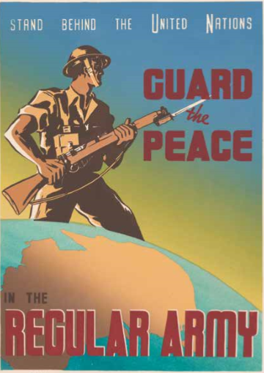

**Source 2**

Extract from a speech in the House of Representatives by Prime Minister R. G. Menzies, July 6, 1950

“On the 27th June … the Security Council recommended that Members of the United Nations furnish such assistance to the Republic of Korea as may be necessary to repel the armed attack and to restore international peace and security in the area … More than 40 members of the United Nations, including all British Commonwealth countries which are members, have accepted the Security Council resolution… [I]t … becomes apparent that the present conflict in Korea is on our side no outburst of old-fashioned power politics. On the contrary, the outcome of the conflict will determine whether the United Nations is efficacious for peace. It would be a tragedy for the world if the United Nations failed in this first crucial trial of strength… These events, which seem so remote in point of space, are not remote in point of significance. They are a reminder that the peace of the world is threatened and that, as a British and democratic nation, we must be not only willing, but also ready. As we are members of the British Commonwealth of Nations, we must be prepared to stand by our sister nations. As we are subscribers not only in the letter but also in the spirit to the Charter of the United Nations, we must be ready to give force and meaning to the letter and spirit of the Charter.”

**SEE NEXT PAGE**

**Source 3**

A souvenir scarf brought back from Korea by an Australian soldier from Canberra.

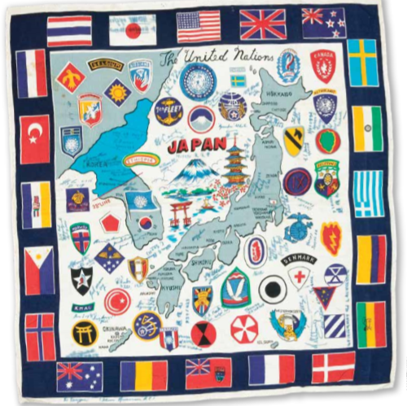

**SEE NEXT PAGE**

**Source 4**

Extract from a collection of essays commissioned by the Australian Army (2000) published in ‘The Korean War 1950-53: A 50 Year Retrospective’. This particular extract is from an essay entitled ‘Australia's War In Korea: Strategic Perspectives And Military Lessons’ by Michael Evans. Evans is a Senior Research Fellow in the Australian Army's Land Warfare Studies Centre, Duntroon.

“…it is clear that the Korean War was a watershed in Australian history in the sense that it marked the decline of the Anglo-Australian military connection and the maturing of the Australia-US bilateral relationship. This reality was obscured for much of the 1950s by the nature of Australian culture as reflected by Menzies' personal Anglophilia, by the continuing ANZAM connection and by Australia's military assistance to Britain during the Malayan Emergency…

The great question, however, remains: was the struggle for South Korea worth the loss of Western life in general and of Australian life in particular?56 The American combat historian, SLA Marshall, who experienced the two world wars, Korea and Vietnam, once described the Korean conflict as 'the century's nastiest war'.57 He may have exaggerated but there is little doubt that, in the 1950s to many Australians and Americans, the Korean War seemed to have been a thankless and inglorious task. The fact that the Korean War was a bellum justum—the use of force to put down wrongful action—was a poor consolation to those Western soldiers who went home to changing and often indifferent societies that were yet to come to terms with the reality of limited war.”

**END OF SOURCE SET**

**Set 6: The struggle for peace in the Middle East**

**Source 1**

A 1950 newspaper advertisement from BP (British Petroleum) published in the United Kingdom (who in 1922 had established the Anglo-Iranian Oil Company to secure its oil supplies in from what was then known as Persia).

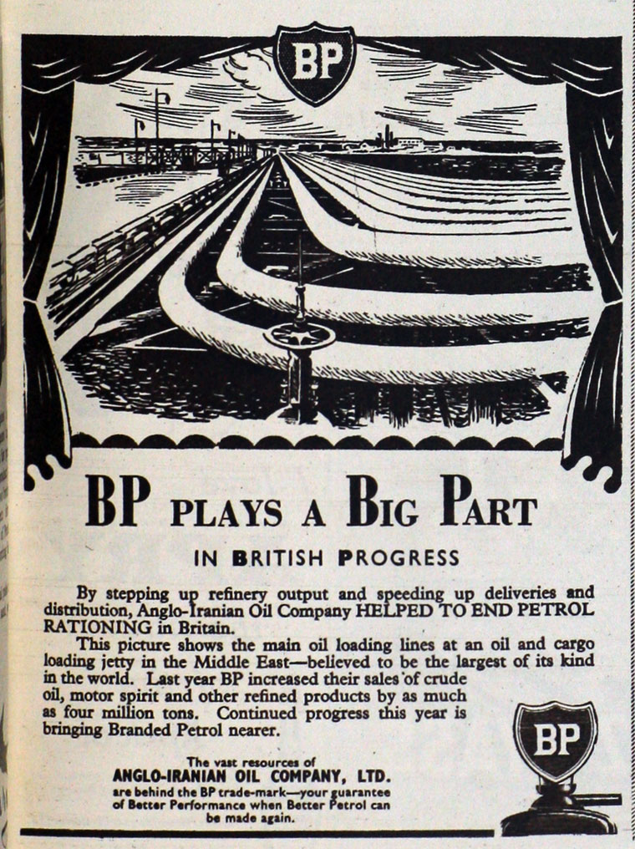

**SEE NEXT PAGE**

**Source 2**

Extract from a translated text of ‘The Khartoum Resolution’ of 1 September 1967 was issued at the conclusion of the 1967 Arab League summit convened in the wake of the Six-Day War, in Khartoum, the capital of [Sudan](https://en.wikipedia.org/wiki/Sudan). The summit lasted from 29 August to 1 September and was attended by eight Arab heads of state: Egypt, Syria, Jordan, Lebanon, Iraq, Algeria, Kuwait, and Sudan.

*“…4.* The conference of Arab Ministers of Finance, Economy and Oil recommended that suspension of oil pumping be used as a weapon in the battle. However, after thoroughly studying the matter, the summit conference has come to the conclusion that the oil pumping can itself be used as a positive weapon, since oil is an Arab resource which can be used to strengthen the economy of the Arab States directly affected by the aggression, so that these States will be able to stand firm in the battle. The conference has, therefore, decided to resume the pumping of oil, since oil is a positive Arab resource that can be used in the service of Arab goals. It can contribute to the efforts to enable those Arab States which were exposed to the aggression and thereby lost economic resources to stand firm and eliminate the effects of the aggression. The oil-producing States have, in fact, participated in the efforts to enable the States affected by the aggression to stand firm in the face of any economic pressure.

*5.* The participants in the conference have approved the plan proposed by Kuwait to set up an Arab Economic and Social Development Fund on the basis of the recommendation of the Baghdad conference of Arab Ministers of Finance, Economy and Oil.

*6.* The participants have agreed on the need to adopt the necessary measures to strengthen military preparation to face all eventualities.

*7.* The conference has decided to expedite the elimination of foreign bases in the Arab States.”

**SEE NEXT PAGE**

**Source 3**

Cartoon by Ranan Lurie published in the Sunday edition of ‘The Times’, London 1974. Lurie is a well-known cartoonist. A Jew born in Israel into a family who had resided there for 6 generations, Lurie fought in the 1948 War of Independence and subsequent conflicts. In 1970, Luri emigrated to the United States where he was widely published in mainstream newspapers around the world.

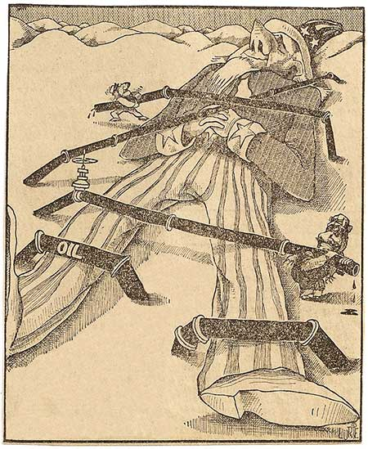

**SEE NEXT PAGE**

**Source 4**

Extract from a chapter entitled “The Political Economy of Middle Eastern Oil” from a collection of essays published in “Understanding the Contemporary Middle East” (2013) by Mary Ann Tétreault. Tétreault was a Distinguished Professor of International Affairs at Trinity University, Texas whose doctoral dissertation was on ‘Arab Oil Exporters in the Persian Gulf”

“…Oil has given a number of Middle Eastern countries the economic independence to try development strategies and to form political bonds that are foreclosed to poorer states. It has also served as a substitute for conventional--that is, military--attributes of power, forcing other nations to reexamine their own foreign policies in the light of long-term economic interests. Thus, it has helped to break down the post-war dominance of the super-powers by providing incentives for greater independence on the part of their alliance partners and extra-regional clients and dependencies. But oil also instilled a false sense of power and a false sense of long-term economic security in the minds of policy makers in oil exporting states…Despite the opportunities that oil has conferred, its exploitation has also exacted high social, political, and economic costs. Uncertain what new regional order will rise on the debris left by recent rapid political changes in the Middle East, we can only speculate whether oil has been a blessing or a curse to its nations and their peoples.”

**END OF SOURCE BOOKLET**

**ACKNOWLEDGEMENTS**

**Set One Australia 1918–1955**

**Source 1** Changing role for Australian women World War One. Retrieved from https://www.abc.net.au/news/2017-07-18/sister-pear-corkhill-receiving-military-medal/8720490

**Source 2** Changing role for Australian women World War Two. Retrieved from https://www.booktopia.com.au/when-the-war-came-to-australia-joanna-penglase/prod9781863733205.html

**Source 3** The post war Australian woman in politics. Retrieved from http://john.curtin.edu.au/legacyex/women.html

**Source 4** Historiography Australian women at war. Retrieved from https://www.vogue.com.au/culture/features/the-role-of-australian-women-at-war/news-story/fc9001d92ef14d8e975bb712052d128c

**Set Two Russia and the Soviet Union 1914–1945**

**Source 1** Changing role of women in Russian Civil War. Retrieved from https://www.rferl.org/a/the-horror-of-russias-civil-war-in-photos-from-red-cross-mission/29699442.html

**Source 2** Perspectives on the changing role for women under Lenin. Retrieved from https://www.marxists.org/archive/krupskaya/works/krup1.htm

**Source 3** Soviet women during World War Two propaganda. Retrieved from http://windowsonwar.nottingham.ac.uk/poster/Glory-to-Mother-Heroines

**Source 4** Historiography changes for women in the soviet period. Retrieved from https://www.researchgate.net/publication/311385232_Celebrating_Women_Gender_Festival_Culture_and_Bolshevik_Ideology_1910-1939_Pittsburgh_University_of_Pittsburgh_Press_2002

**Set Three China 1935–1989**

**Source 1** Women in China before the revolution 1938. Retrieved from http://www.historic-shanghai.com/mctyeire-school-for-chinas-daughters**/**

**Source 2** Mao Zedong thoughts on the role of women in revolution. Retrieved from https://www.marxists.org/reference/archive/mao/works/red-book/ch31.htm

**Source 3** Chinese propaganda posters women. Retrieved from https://movieposters.ha.com/itm/movie-posters/foreign/women-can-hold-up-half-the-sky-and-other-lot-1975-chinese-propaganda-posters-2-21-x-3025-foreign-total-2-items-/a/161741-52050.s

**Source 4** Historiography the changing role of women in China. Retrieved from https://vc.bridgew.edu/cgi/viewcontent.cgi?referer=&httpsredir=1&article=1626&context=jiws

**Set Four The changing European world since 1945**

**Source 1** Protests against the Cuban Missile Crisis. Retrieved from https://www.alamy.com/women-strike-for-peace-holding-placards-relating-to-the-cuban-missile-image60095039.html

**Source 2** Soviet response to the Cuban Missile Crisis. Retrieved from http://www.atomicarchive.com/Docs/Cuba/khrushchevletter2.shtml

**Source 3** Punch cartoon Cuban Missile Crisis. Retrieved from https://punch.photoshelter.com/image/I0000KJx5ZVh3U5I

**Source 4** Historiography Cuban Missile Crisis. Retrieved from https://news.usni.org/2012/10/24/soviet-perspective-cuban-missile-crisis-nikita-khrushchevs-son

**Set Five Australia’s engagement with Asia**

**Source 1** Australian propaganda Korean War. Retrieved from https://www.awm.gov.au/collection/C1116188

**Source 2** Menzies announces Australia’s involvement in Korea. Retrieved from https://anzacportal.dva.gov.au/file/1187/download

**Source 3** Visual images Australia’s involvement in Korea. Retrieved from https://anzacportal.dva.gov.au/file/1187/download

**Source 4** Historiography – Australia and the Korean War. Retrieved from https://www.army.gov.au/sites/g/files/net1846/f/2000_chief_of_army_conference_korean_war_0.pdf

**Set Six The struggle for peace in the Middle East**

**Source 1** British oil in the Middle East. Retrieved from https://www.gracesguide.co.uk/BP

**Source 2** Arab perspectives on oil 1960s. Retrieved from https://mfa.gov.il/MFA/ForeignPolicy/MFADocuments/Yearbook1/Pages/31%20Resolution%20Adopted%20at%20the%20Arab%20Summit%20Conferenc.aspx

**Source 3** Jewish perspectives on oil in Middle East cartoon. Retrieved from https://www.haaretz.com/israel-news/culture/.premium.MAGAZINE-the-renowned-cartoonist-who-was-almost-recruited-by-the-mossad-1.5444188

**Source 4** Historiography oil as an Arab weapon. Retrieved from https://pdfs.semanticscholar.org/67a6/b3d396b50a88733c06a527c2abeb65e0e685.pdf